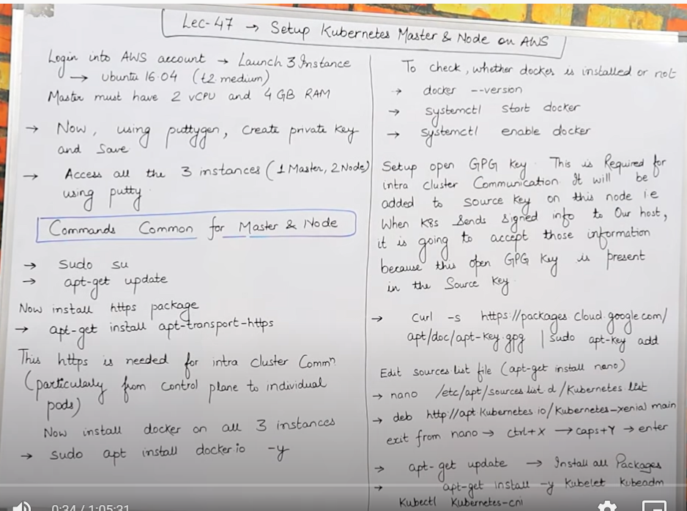

* Create 3 instance , jisme sein eak instance ko master banaunga aur 2 ko node

.

* Master banane kein liye minimum **2 virtual cpu** hona chahihye aur **4 gb ram** minimum hona chahiye humare machine mein isliye aws ki t2 micro kaam nahi aayega yaha, toh isliye liye hum **t2 medium** le lenge yaha .

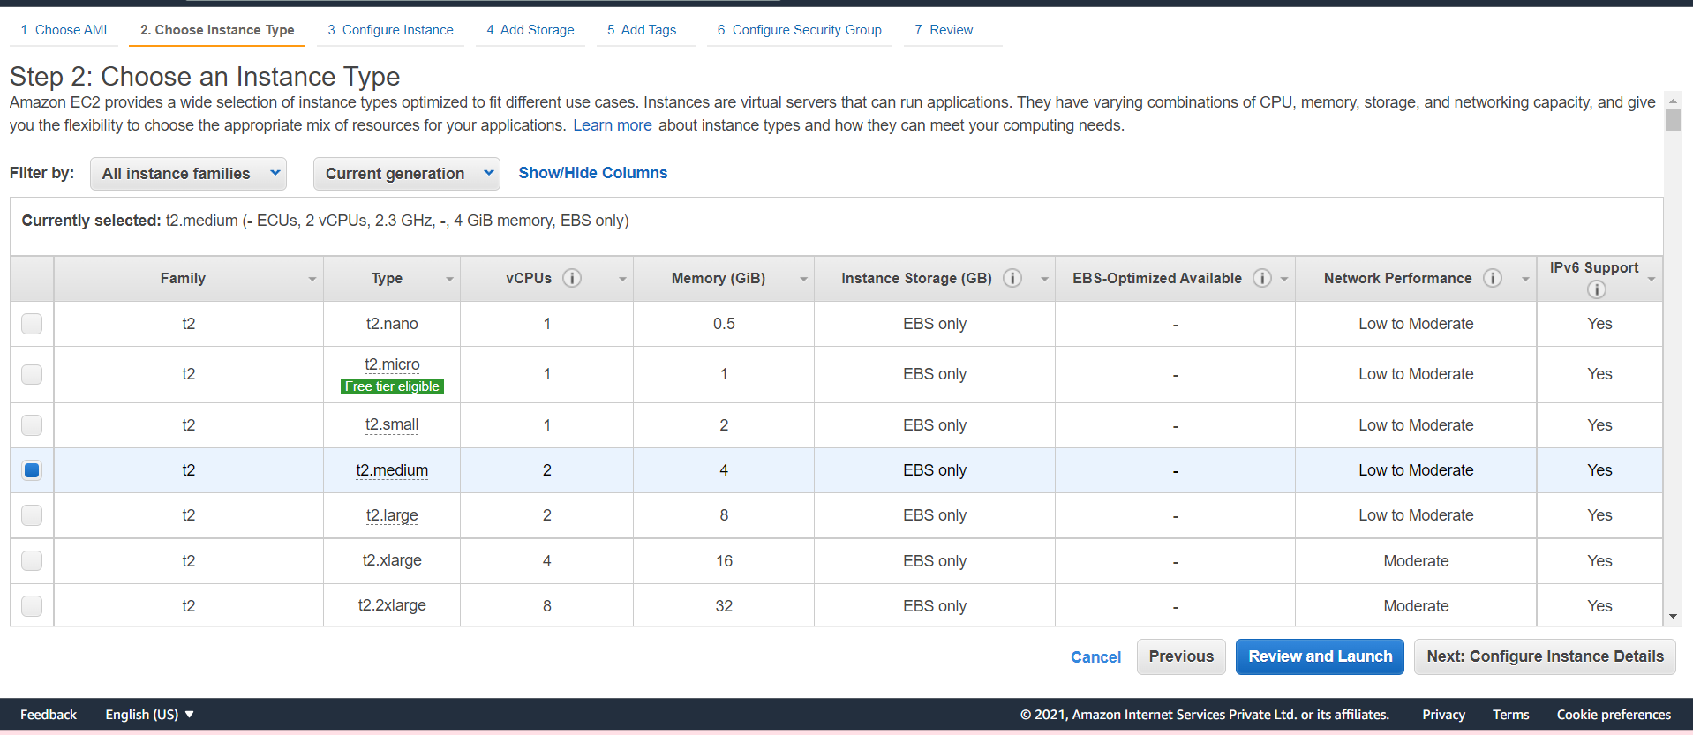

* Now 1 master and 2 node , abhi mene 3 instance bana kein bas usme sein eak decide kar diya ki eak master hai baki 2 node hai.

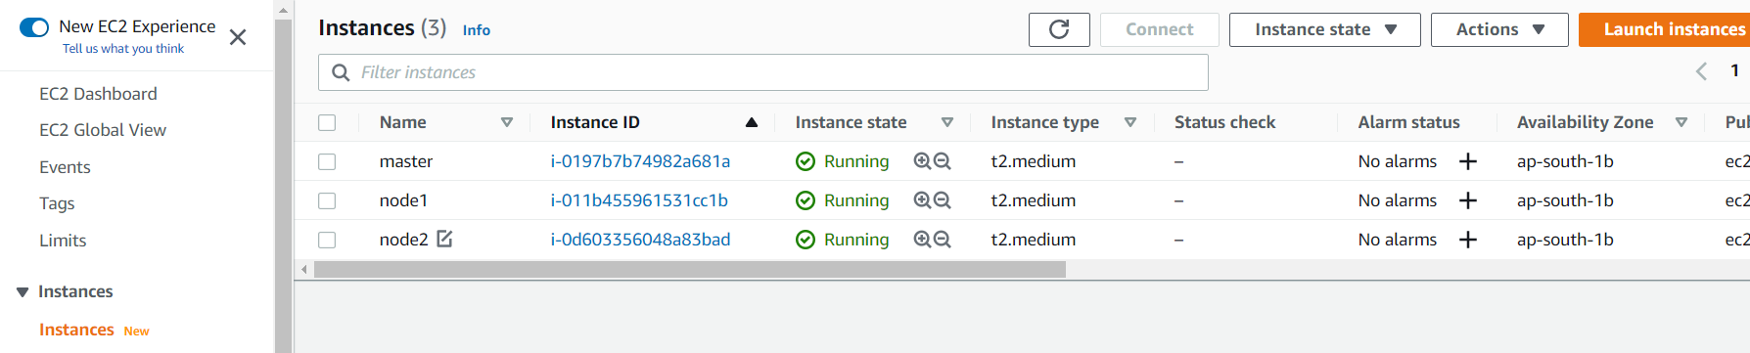

**Master =**

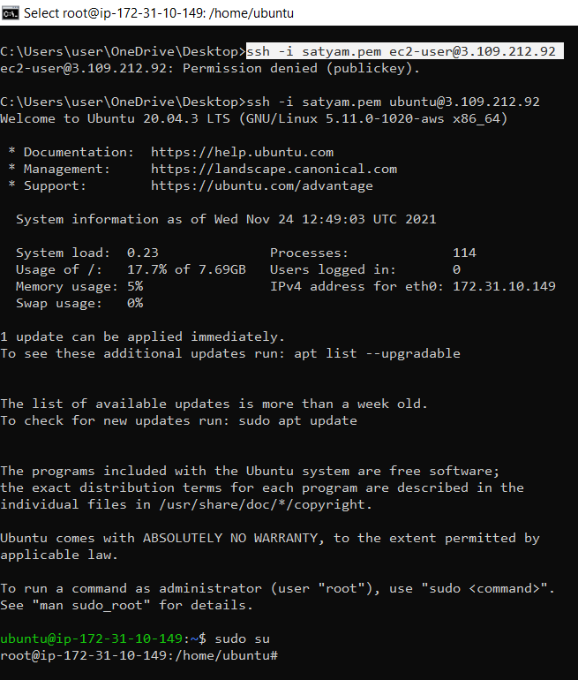

**Node 1 = Grey terminal**

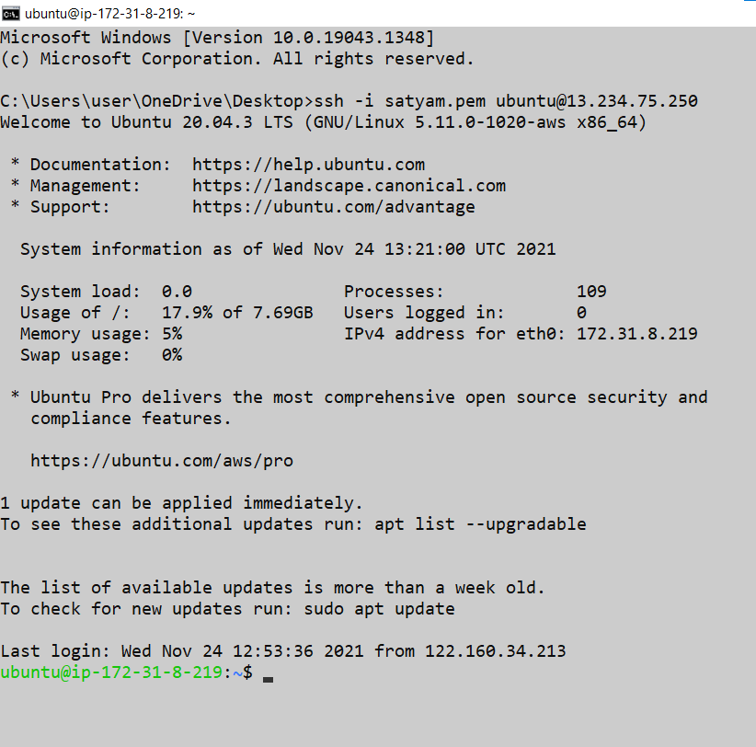

Node 2 = yellow terminal

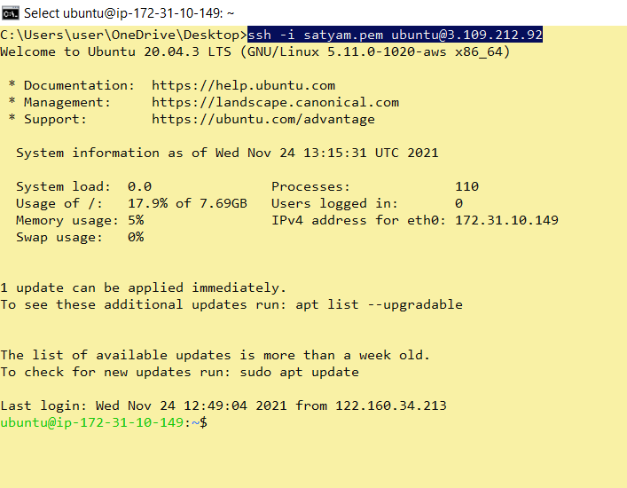

* apt-get update

**Master Node1 Node2**

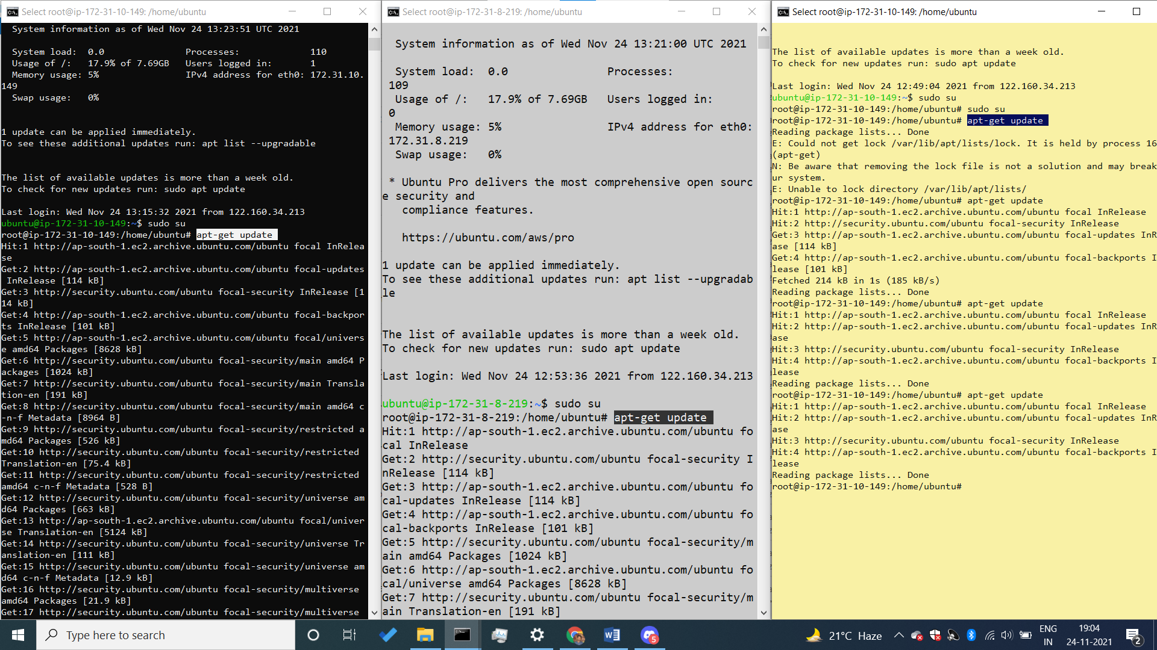

* apt-get install apt-transport-https
* agar humko secure level par kuch karna hai toh uske liye humein **https** install karna hoga.

Master Node1 Node2

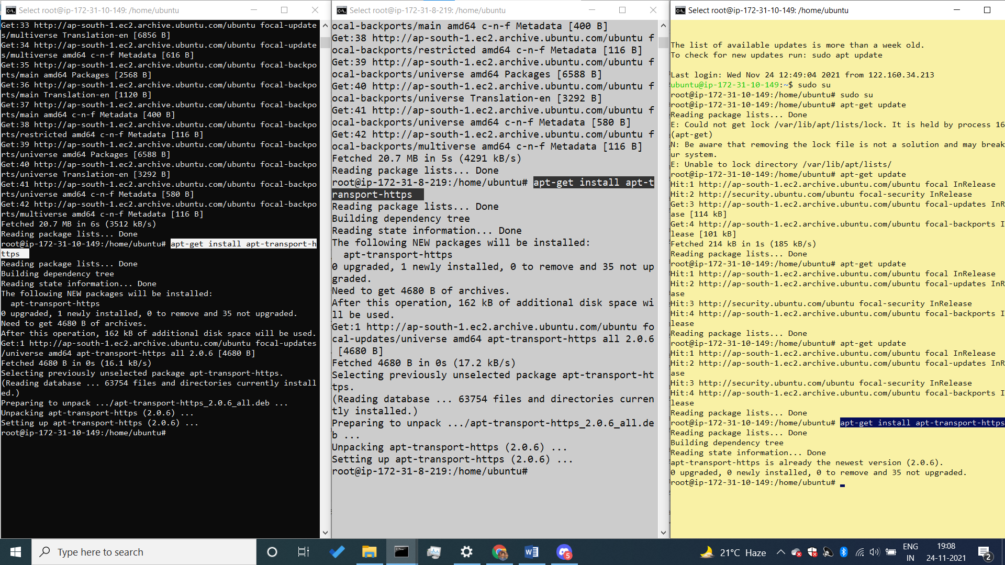

* apt install docker.io –y
* docker install (humane master aur worker node mein sab mein docker install kar diya hai)

Master Node1 Node2

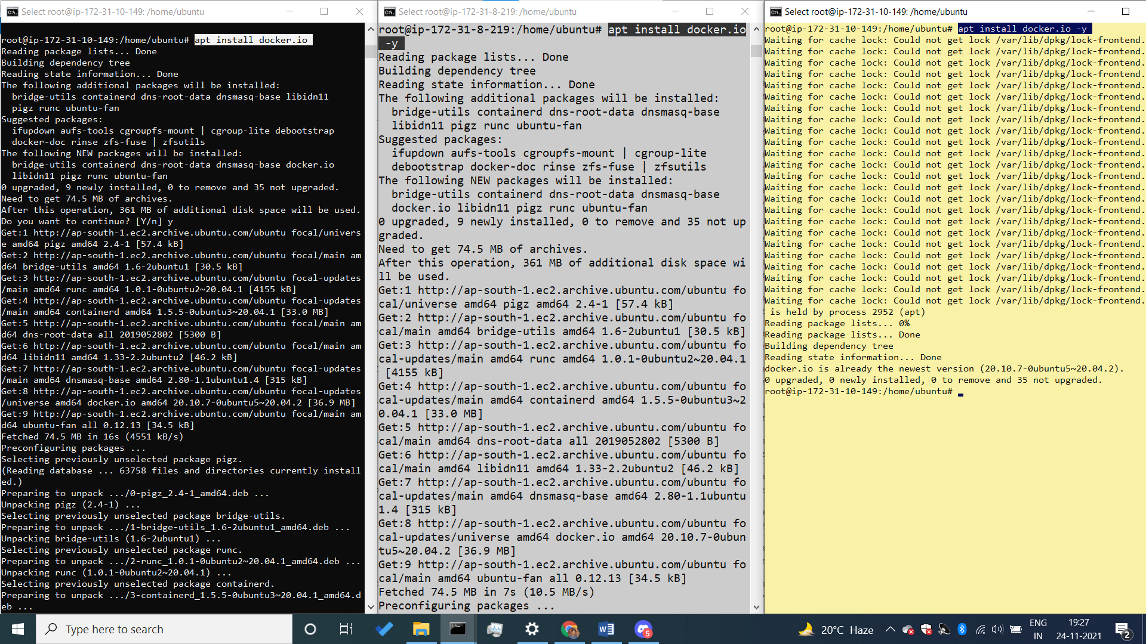

* stystemctl start docker

(mene docker install karne ken baad docker ko start kiya hai )

Master Node1 Node2

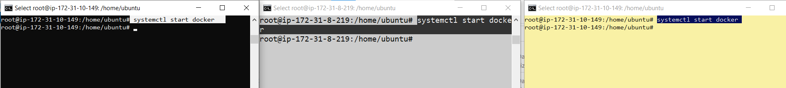

* systemctl enable docker

(docker ko enable kar diya hai)

Master Node1 Node2

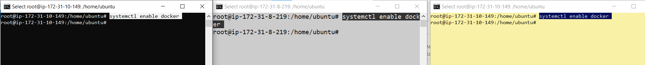

* - - - - - - - - - - - - - - - - - -- - - - - - - - - - - - - - - - - - - - - - -- - - -- - - - - - - - - - - - - - - - - - - - - - - -- - - - - - - -
* GPG KEY = Master ko jab bhi node sein baat karna ho toh dono kein pass GPG key hona chahiye jisase NODE ko ye confirm ho ki jo samne vala banda matlab master hai uske pass bhi same key hai authenticatication kein liye agar key match ho rahi toh conversastion ho jayegi master aur worker node mein,

* GPG key ka use karne kein liye humko gpg key kein package ko install karna hoga .
* GPG-key ko install karne kein liye hum ye command use karenge , hum link kein andar dekhenge ki eak package hai jo ki hum google.com sen uthaa rahe hai , aur humane directory bhi bata diya hai ki iss directory mein package rakha hai yaha sein jaake uthaa lo, aur last mein mene sudo apt-key add isliye likha hai ki meri ye key master par bhi laga do aur worker node par bhi attach kar do .
* sudo curl -s https://packages.cloud.google.com/apt/doc/apt-key.gpg | sudo apt-key add

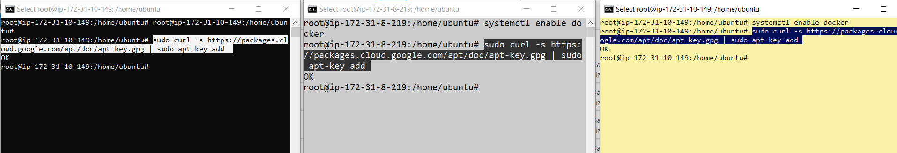

**Install kubernetes**

* Kubernetes ko install karane kein liye sabse pehale mene eak file banayi hai nano ki help sein, us file kein andar mene link dala hai jaha sein humko kubernetes ka package download karna hai, us link kein through humko us file kein andar download karna hai kubernetes kein package
* nano command hum tab use karte hai jab humko koi file bannai hai aur us file kein andar humko agar kuch edit karna hai toh vaha hum nano command use karte hai , aur hum command mein dekhenge ki humane eak path diya hai aur path kein andar eak source.list .d kein naam sein eak file hogi uske andar hum jaake **kubernetes.list** kein naam sein eak file create karenge .
* **nano /etc/apt/sources.list.d/kubernetes.list**

**---------------------------------------------------------------------------------------------------------------**

* aur nano file jab open ho jaye toh uske andar hum yein command daal denge , link mein **deb** ka matlab hai **debian family** ka use kare aur deb kein baad mene kubernetes ki **official website** di hai, aur us link par jane kein baaad mene eak package ka naam likha hai jiska naam hai **kubernetes-xenial** download kar le aur uske package kein andar bhi huko **main** vali file download karna hai, matlab main vala package download karna hai, command likhane kein baad file ko save kar dena hai , file save karne kein liye **ctrl+x => ctrl+y => enter**
* **deb https://packages.cloud.google.com/apt/ kubernetes-xenial main**

**master**

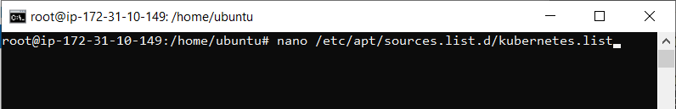

**Master**

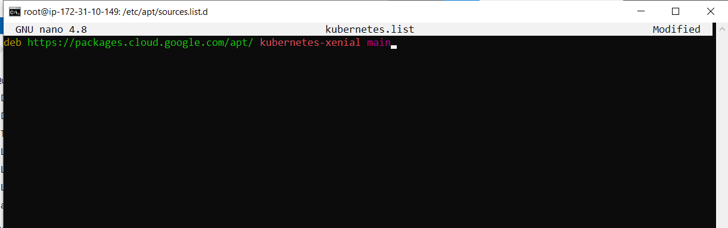

**Node1 Node2**



**Node1 Node2**



**--------------------------------------------------------------------------------------------------------------**

* Now we want to update our packages, iska matlab jo humane upar **kubernetes-xenial** naam ka package download kiya thaa vo install ho jayega
* apt-get update hum yaha isliye likhe hai ki upar mene jo kubernetes-xenial file dali hai usko unzip kar do.

**apt-get update**

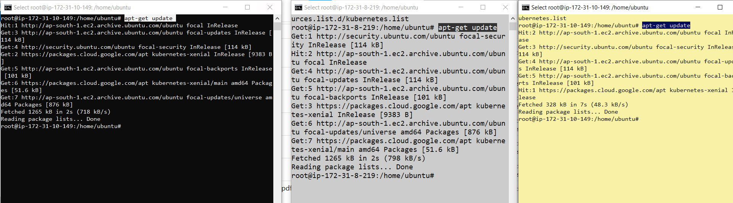

* Jab humara package unzip ho jayega uske andar bhi humko bahut saree packages hai jo ki install karna jaruri hai
* **apt-get install -y kubelet kubeadm kubectl kubernetes-cni**

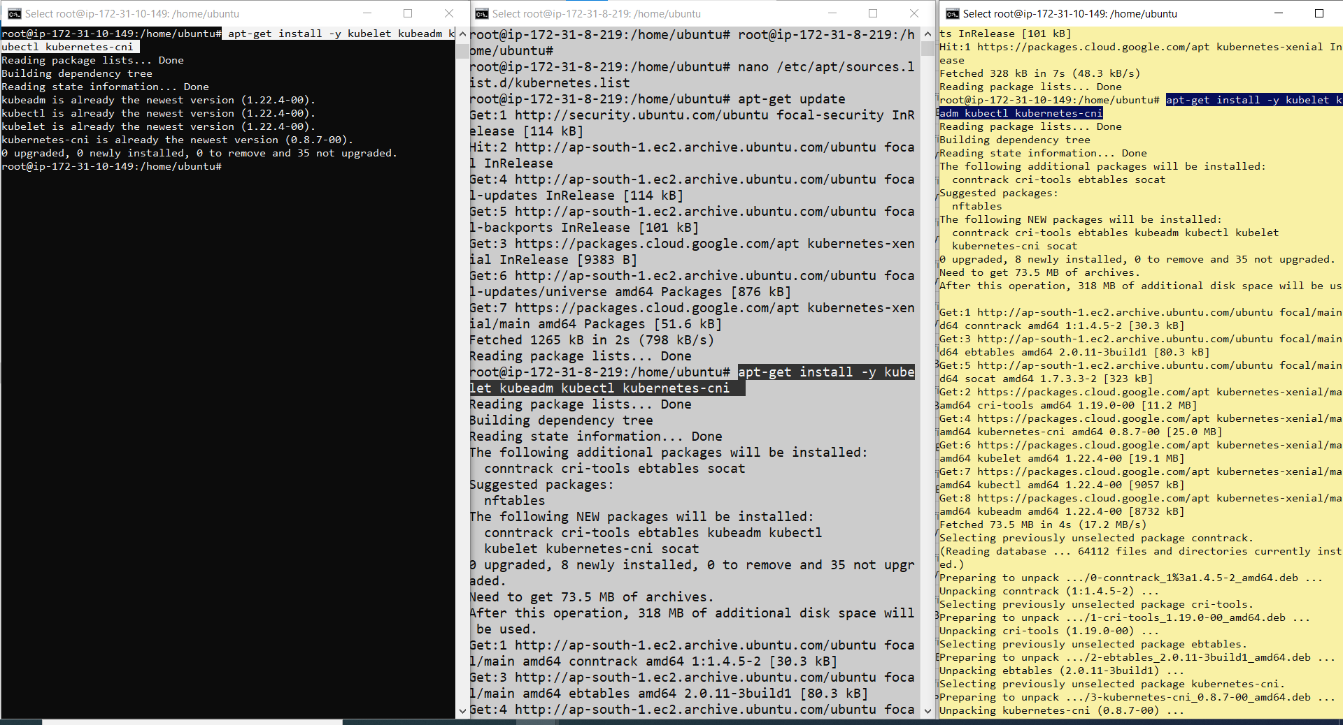

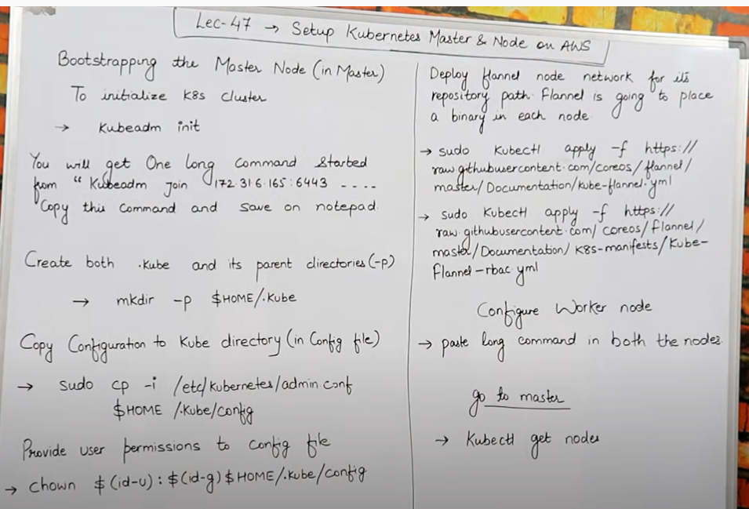

* **Bootstraping ka matlab hai master ko humare node kein sath connect karna, matlab master aur node kein beech mein connection karna aur path ko hi hum bootstrapping kehate hai.**
* **Create master node**
* Sabse pehale master aur worker node ko jodane kein liye humko master node banana padega, aur master node banana kein liye hum master ko initialize karenge, aur ye command chalayenge, **aur initialize hone kein baad eak lamba sa code aayega jisko hum copy karke rakh lenge apane notepad mein**
* Master banana kein liye minimum 2 virtual cpu hona chahihye aur 4 gb ram minimum hona chahiye humare machine mein isliye aw ski t2 micro kaam nahi aayega yaha, toh iske liye hum t2 medium le lenge yaha
* **kubeadm init :-**

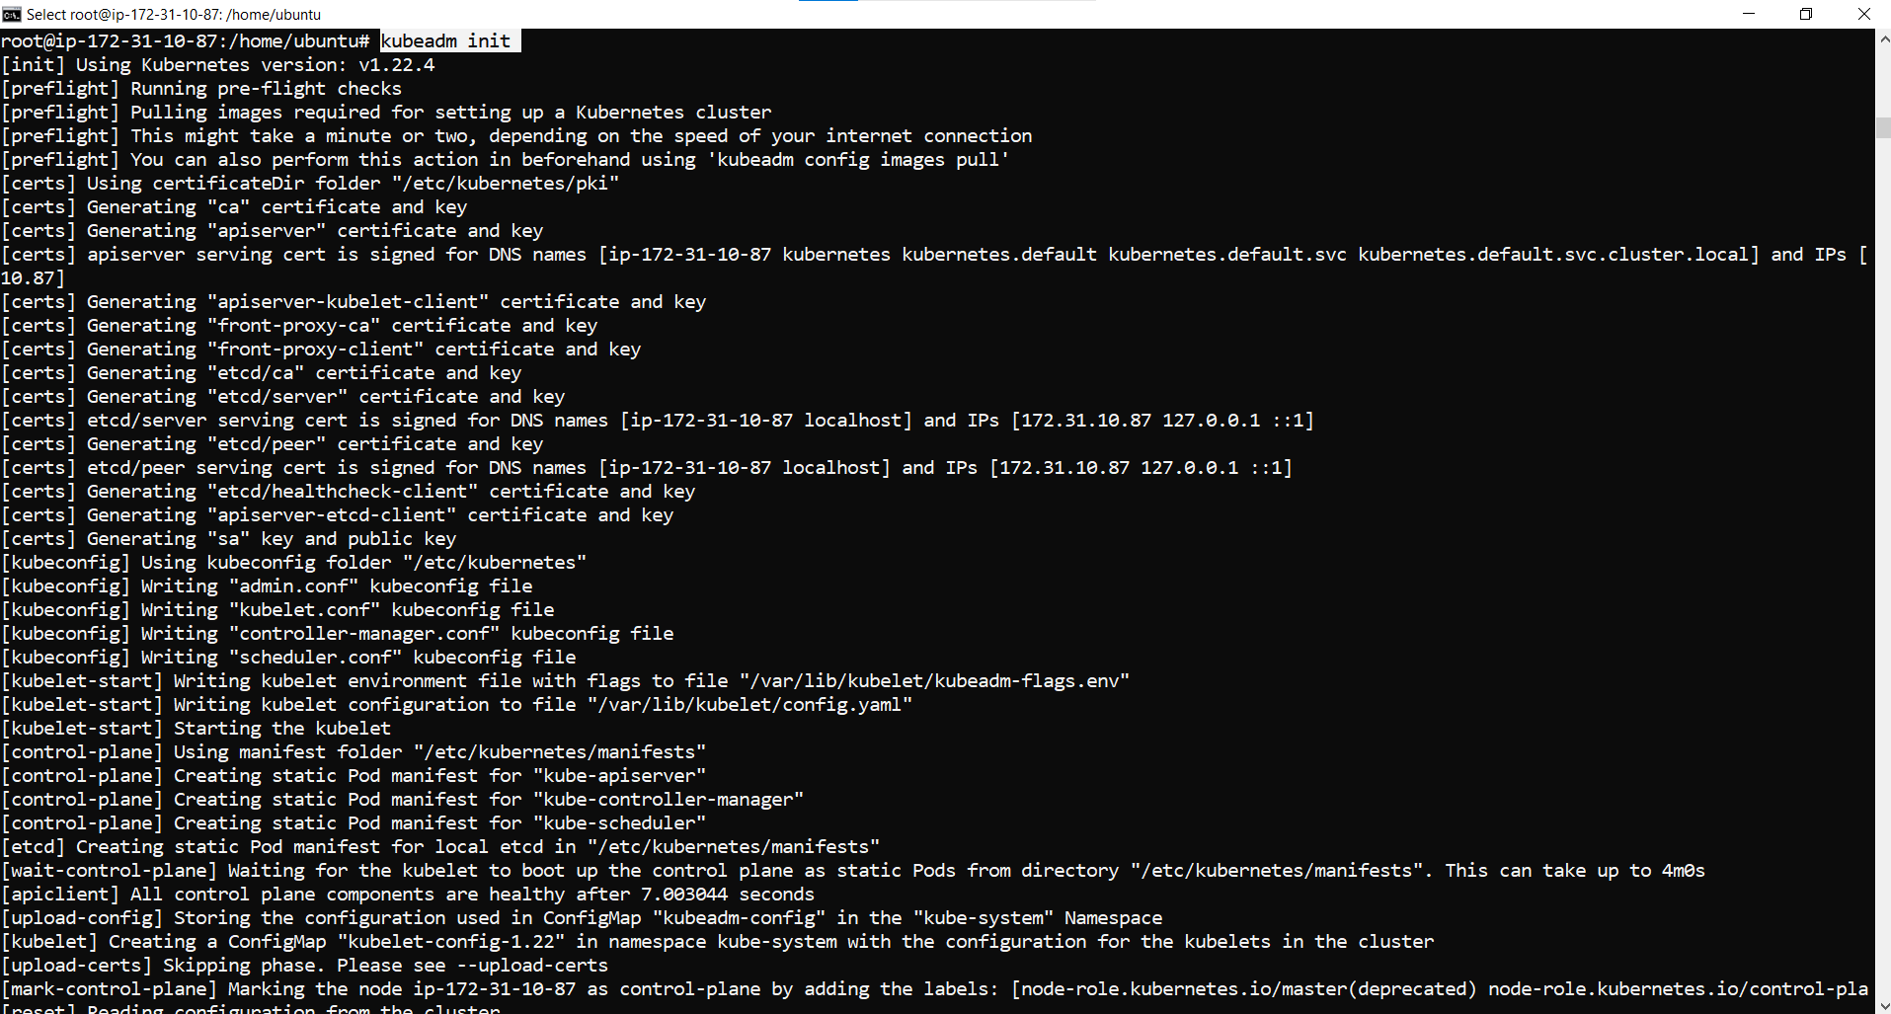

* **key:-**  ye jo key humko millegi isko hum save karke rakh lenge aur hum is key ko apane worker node mein dalenge hum and tab humari master jaa kein worker node sein connect ho jayegi.

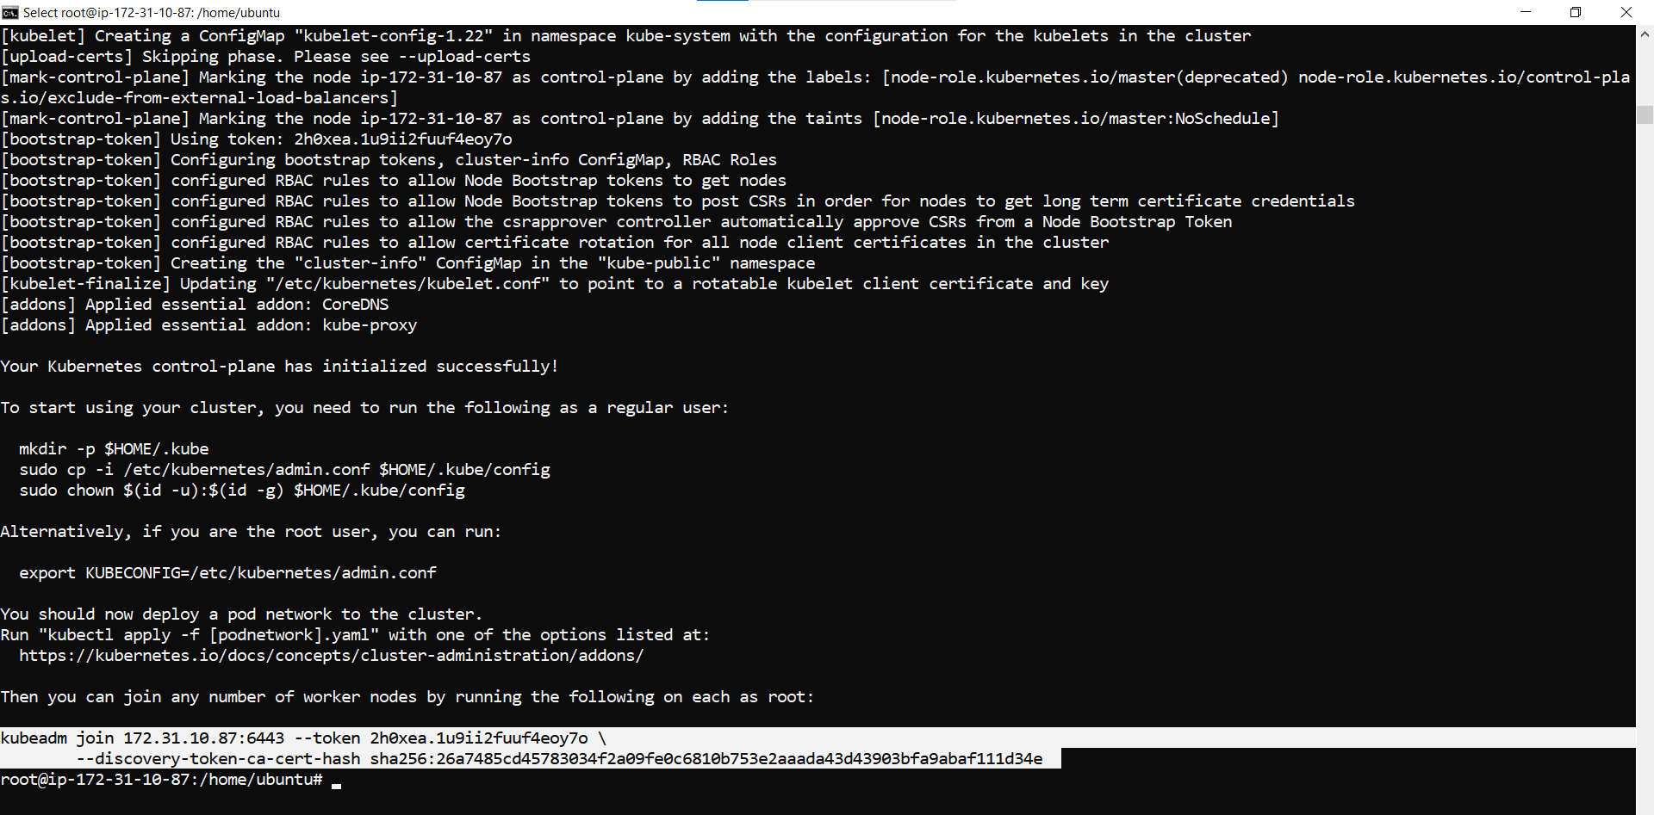

**Save key :-**

**kubeadm join 172.31.10.87:6443 --token e1imnk.nq72dd3nsshhcg3c --discovery-token-ca-cert-hash sha256:d03f04cf494f6f03d72b98788fd41960536f58112952cad459a97bccb43b8e75**

* hum jab key dalenge toh beech mein slash/ hata denge aur kewal eak space denge beech mein .
* Agar kubeadm init karne mein key generate nahi ho rahi aur error aa raha ho toh hum ye command chalayenge phir uske baad kubeadm init karenge.
* I am facing an error while performing lab and using the command kubeadm init. And solved the problem by using the following steps/commands:

[**vim**](https://www.youtube.com/hashtag/vim) **/etc/docker/daemon.json**

{

"exec-opts": ["native.cgroupdriver=systemd"]

}

**sudo** [**systemctl**](https://www.youtube.com/hashtag/systemctl) **daemon-reload**

**sudo** [**systemctl**](https://www.youtube.com/hashtag/systemctl) **restart docker**

sudo [**systemctl**](https://www.youtube.com/hashtag/systemctl) **restart kubelet**

**sudo** [**kubeadm**](https://www.youtube.com/hashtag/kubeadm) **init**

**-------------------------------------------------------------------------------------------------------------------------------------**

* Humara master node jab initialize hojayega toh uske baad hum kuch command chalayenge jo ki humko initialize hone kein baad vaha dikhengei , humko ye 3 command dikhegi console par initialize hone kein baad
* **1 st command =** mkdir -p $HOME/.kube

Is command sein hum parent directory create karenge isliye mene **–p** likha hai ki parent kein liye eak directory create kar do



* **2 nd command =** cp -i /etc/kubernetes/admin.conf $HOME/.kube/config

Is command sein hum jo upar jo **.kube** naam ki directory banaya hai uske andar hum copy karenge , matlab kubernetes kein andar jo admin.config naam ki file hai **(/etc/kubernetes/admin.)** usko hum copy karenge is path par **(HOME/.kube/config ).**matlab .kube mein jaake config kein andar copy ho jayegi

Admin.config aur $HOME kein pehale space bhi hoga.



* 3 rd command = chown $(id -u):$(id -g) $HOME/.kube/config

Provide user permission to config file, matlab agar humko user ko kya permission dena hai isliye mene likha hai starting mein **chown means change owner permission** iska matlab user kaun si permission change kar payega kaun sid nahi humko vo dikha dega jab command chalayenge aur vo by default kubernetes kar bhi deta hai. Aur ye 3 ki 3 sab command master mein hi run karenge.



**Run those 2 commands:-**

kubectl apply -f <https://raw.githubusercontent.com/coreos/flannel/master/Documentation/kube-flannel.yml>

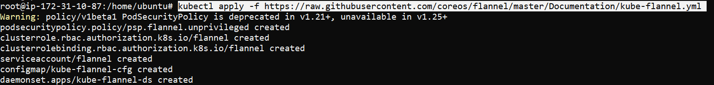

kubectl apply –f <https://raw.githubusercontent.com/coreos/flannel/master/Documentation/k8s-manifests/kube-flannel-rbac.yml>



--------------------------------------------------------------------------------------------------------------------------------------

* Ab mene jo upar master initialize karte samaye jo code copy karke notepad mein rakha thaa usko uthaunga aur us code ko le jake apane node mein daal dunga jisase humara master aur worker node sab eak sath connect ho jayenge, aur isko hi hum bootstrapping kehate hai .
* Aba agar mujhe check karna ho ki mera master kein sath mera worker node connect huva hai ya nahi uske liye hum ye command likhenge.

-------------------------------------------------------------------------------------------------------------------------------------------------------------------------

**worker node :- run this command in all the node those you want to connect to master.sp**

[**vim**](https://www.youtube.com/hashtag/vim) **/etc/docker/daemon.json**

{

"exec-opts": ["native.cgroupdriver=systemd"]

}

**sudo** [**systemctl**](https://www.youtube.com/hashtag/systemctl) **daemon-reload**

**sudo** [**systemctl**](https://www.youtube.com/hashtag/systemctl) **restart docker**

sudo [**systemctl**](https://www.youtube.com/hashtag/systemctl) **restart kubelet**

**kubeadm join 172.31.10.87:6443 --token e1imnk.nq72dd3nsshhcg3c --discovery-token-ca-cert-hash sha256:d03f04cf494f6f03d72b98788fd41960536f58112952cad459a97bccb43b8e75**

-------------------------------------------------------------------------------------------------------------------------------------------------------------------------

GO TO MASTER AND RUN THIS COMMAND :-

* **kubectl get nodes**
* aur hum master mein jake search karenge toh hum dekhenege ki humare master kein sath mene jitani node connect ki thii humane vo sab node connected hai . aur unki private ip bhi mujhe show ho rahi hai.

-----------------------------------------------------------------------------------------------------------------------